Hon. Debbie Wasserman Schultz Event Memo

May 6, 2016

**DEMOCRATIC NATIONAL COMMITTEE WLF ROUNDTABLE DISCUSSION**

DATE: Friday – May 6, 2016

**LOCATION: World Live Café at The Queen**

500 N. Market Street

Wilmington, DE 19801

EVENT TIME: 3:00 PM – 5:00 PM EDT

**DWS TIME**: **3:30 PM – 4:30 PM PDT**

CONTACT: Claire Olszewski, WLF Director

202-550-3790 (cell)

1. PURPOSE & FORMAT:

**YOU** will participate in a roundtable discussion with 28 Women’s Leadership Forum supporters at the World Live Café. Attendees at this discussion have been active in local politics in DE, NJ, and PA and a few have attended WLF conferences in the past. A few attendees are members of College Dems leadership in PA. All attendees want to be involved in defining and solving problems that affect women and are especially interested in learning strategies to engage women in this election cycle. The purpose of this roundtable is to have an interactive discussion with guests about the current state of the election and encourage them to become active DNC and WLF supporters. Please thank them for their support, give them ideas about how they can be most helpful to our cause, and tell them about DNC plans in 2016.

1. PRESS PLAN

Closed Press.

1. PARTICIPANTS
   * **YOU**
   * Senator Tom Carper
   * 28 Discussion Attendees
2. ACKNOWLEDGEMENTS

* Please acknowledge Senator Tom Carper
* Please acknowledge event hosts: Marijo Lucas and Robin Whitaker

1. SEQUENCE OF EVENTS:

3:00 PM Guests arrive.

3:30 PM **YOU** arrive at the venue and are greeted by Senator Tom Carper and event hosts, Marijo Lucas and Robin Whitaker.

3:32 PM **YOU** are escorted inside and take your seat.

3:35 PM Robin Whitaker welcomes guests and introduces Senator Tom Carper.

3:37 PM **YOU** are introduced by Senator Tom Carper.

3:40 PM **YOU** deliver informal welcoming remarks.

3:50 PM **YOU** conclude remarks and open the floor to discussion and Q&A.

4:20 PM Claire Olszewski calls for last question

4:30 PM **YOU** conclude Q & A and depart.

1. ATTACHMENTS:

* Host Biographies
* Discussion Attendees
* Talking Points

HOST BIOGRAPHIES

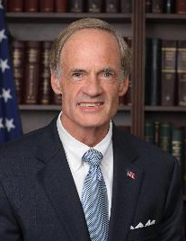

**Senator Tom Carper**

Tom Carper is the senior Senator from Delaware. He served five years as a naval flight officer, served three tours of duty in Southeast Asia during the Vietnam War, and continued to serve in the Naval Reserve as a P-3 aircraft mission commander until retiring with the rank of captain in 1991 after 23 years of military service. He serves as ranking member of the Senate Committee on Homeland Security and Governmental Affairs. He also serves on the Finance Committee and Environment and Public Works Committee.

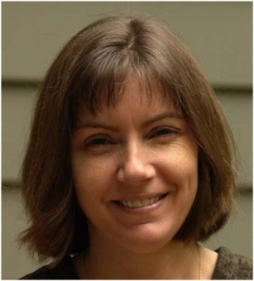**Marijo Lucas, Self, Psychologist**

Dr. Marijo Lucas currently runs her own Psychology practice in Philadelphia and lives in Rockland, DE. She has previously worked as a Professor of Psychology at Immaculata University where she taught classes, guided dissertations, and did research. Marijo has been a consistent DNC supporter since the early 2000s and a member of the WLF since 2010. She is very active in local politics and organizing.

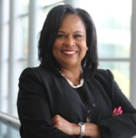**Robin Whitaker, Senior Sustainability Solution Advisor, SAP America Inc.**

Robin Whitaker is a Senior Sustainability Advisor at SAP, a business software developer. She specializes in product safety and sustainable innovations and also serves as a stewardship advisor. Previously, Robin worked at TechniData America in product safety and managed sustainability projects in Xiamen Island of the People’s Republic of China. Robin was a delegate from Delaware at the 2008 Democratic National Convention and has been a supporter of the WLF since 2014.

DISCUSSION ATTENDEES

* **Carrie Awadzi**, Professor, Delaware State University
* **Laura Boston Jones**, Vice President of Behavioral Health Services, North Philadelphia Health System
* **Marge Brown Kaldoner**, Interior Designer, Self-Employed
* **Kesha Clarke**, Psychologist, Philadelphia VA Medical Center
* **Nancy Doorey**, Consultant, Nancy Doorey Educational Consulting
* **Mary Anne Edwards**, Retired
* **Ann Exline-Starr**, Veteran, U.S. Agency for International Development
* **Allyson Galloway**, Psychologist, Center for Neuroscience
* **Deborah Hamilton**, President, AlfordHamilton Associates
* **Shekelia Hines**, Physical Therapist, Bayhealth
* **Sheila Hudson, Retired**
* **Akira Johnson**, IT Specialist, Self-Employed
* **Philip Kaldoner**, Attorney, Self-Employed
* **Karen Kegelman**, Sales, Worldwide Incorporators
* **Kareen Kircher**, Consultant, DevOps Advisors
* **Joyce Kornegay**, Principal, Newark Public Schools
* **Grant Lincoln**, President, College Democrats of Pennsylvania
* **Audrey Lyke**, Energy Policy Analyst, Exelon Corp
* **Kinjal Shah**, Vice President, West Chester College Democrats
* **Maryalice St. Clair**, VP of Business Development, Halosil International
* **Sandra Thorn-Barry**, IT HelpDesk Admin, SAP America Inc.
* **Tiea Thornton**, Behavioral & Educational Therapist, Self-Employed
* **Carol Trotman**, Homemaker
* **Louvenia Vogelsberg**, Retired
* **Karen Wilson-Lynch**, Consultant, QMC Specialists
* **Pamela Witherspoon**, Flight Attendant, American Airlines

TALKING POINTS

See attached.